**Git**

* Git is a specification that provides set of rules and guidelines to create distributed VCS software.
* Git
  + GitHub (Microsoft)
  + Bit Bucket (Atlasian)
  + Gitlab (Microsoft)
  + Azure Repo (Microsoft)
* Git Bash is common git client to connect any vendor managed Git central repository.

**Bitbucket**

* Bitbucket is a Git based distributed VCS software.
* It gives us a central place to manage git repositories.

**Create a New Repository**

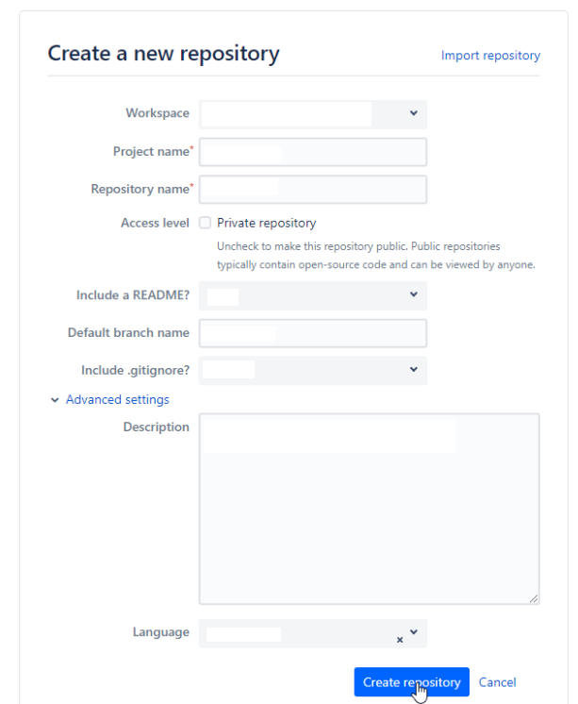

**Install Git**

**Configuring User Name and Email**

git config --global user.name "Sibesh Patel"

git config --global user.email "sibeshpatel9490@gmail.com"

**Create Repo**

Step1:

* Initialize git repository

git init

Step2:

* Create few files

touch data1.txt data2.txt

* Check Status

git status

Step3:

* Move files from working directory to staging area

git add .

Step4:

* Move files from staging area to local repo

git commit -m 'data1.txt, data2.txt added'

Step5:

* Link with remote repo

git remote add origin <git-repo-url>

git branch -M main

Step6:

* Push Code to Remote Repo

git push -u origin main

* It will ask for authentication.